Casey Gray
ITEC 4365
April 15, 2025
Program 4

In an email, you told me that since I had completed the assignment before I was able to take screenshots of the earlier steps, that I would be exempt from this assignment, but I wanted to at least send screenshots of my final functional_tests.py running and the final test.

- Functional_tests.py (I took the screenshot before “4: Use peacock feathers to make a fly” appeared.
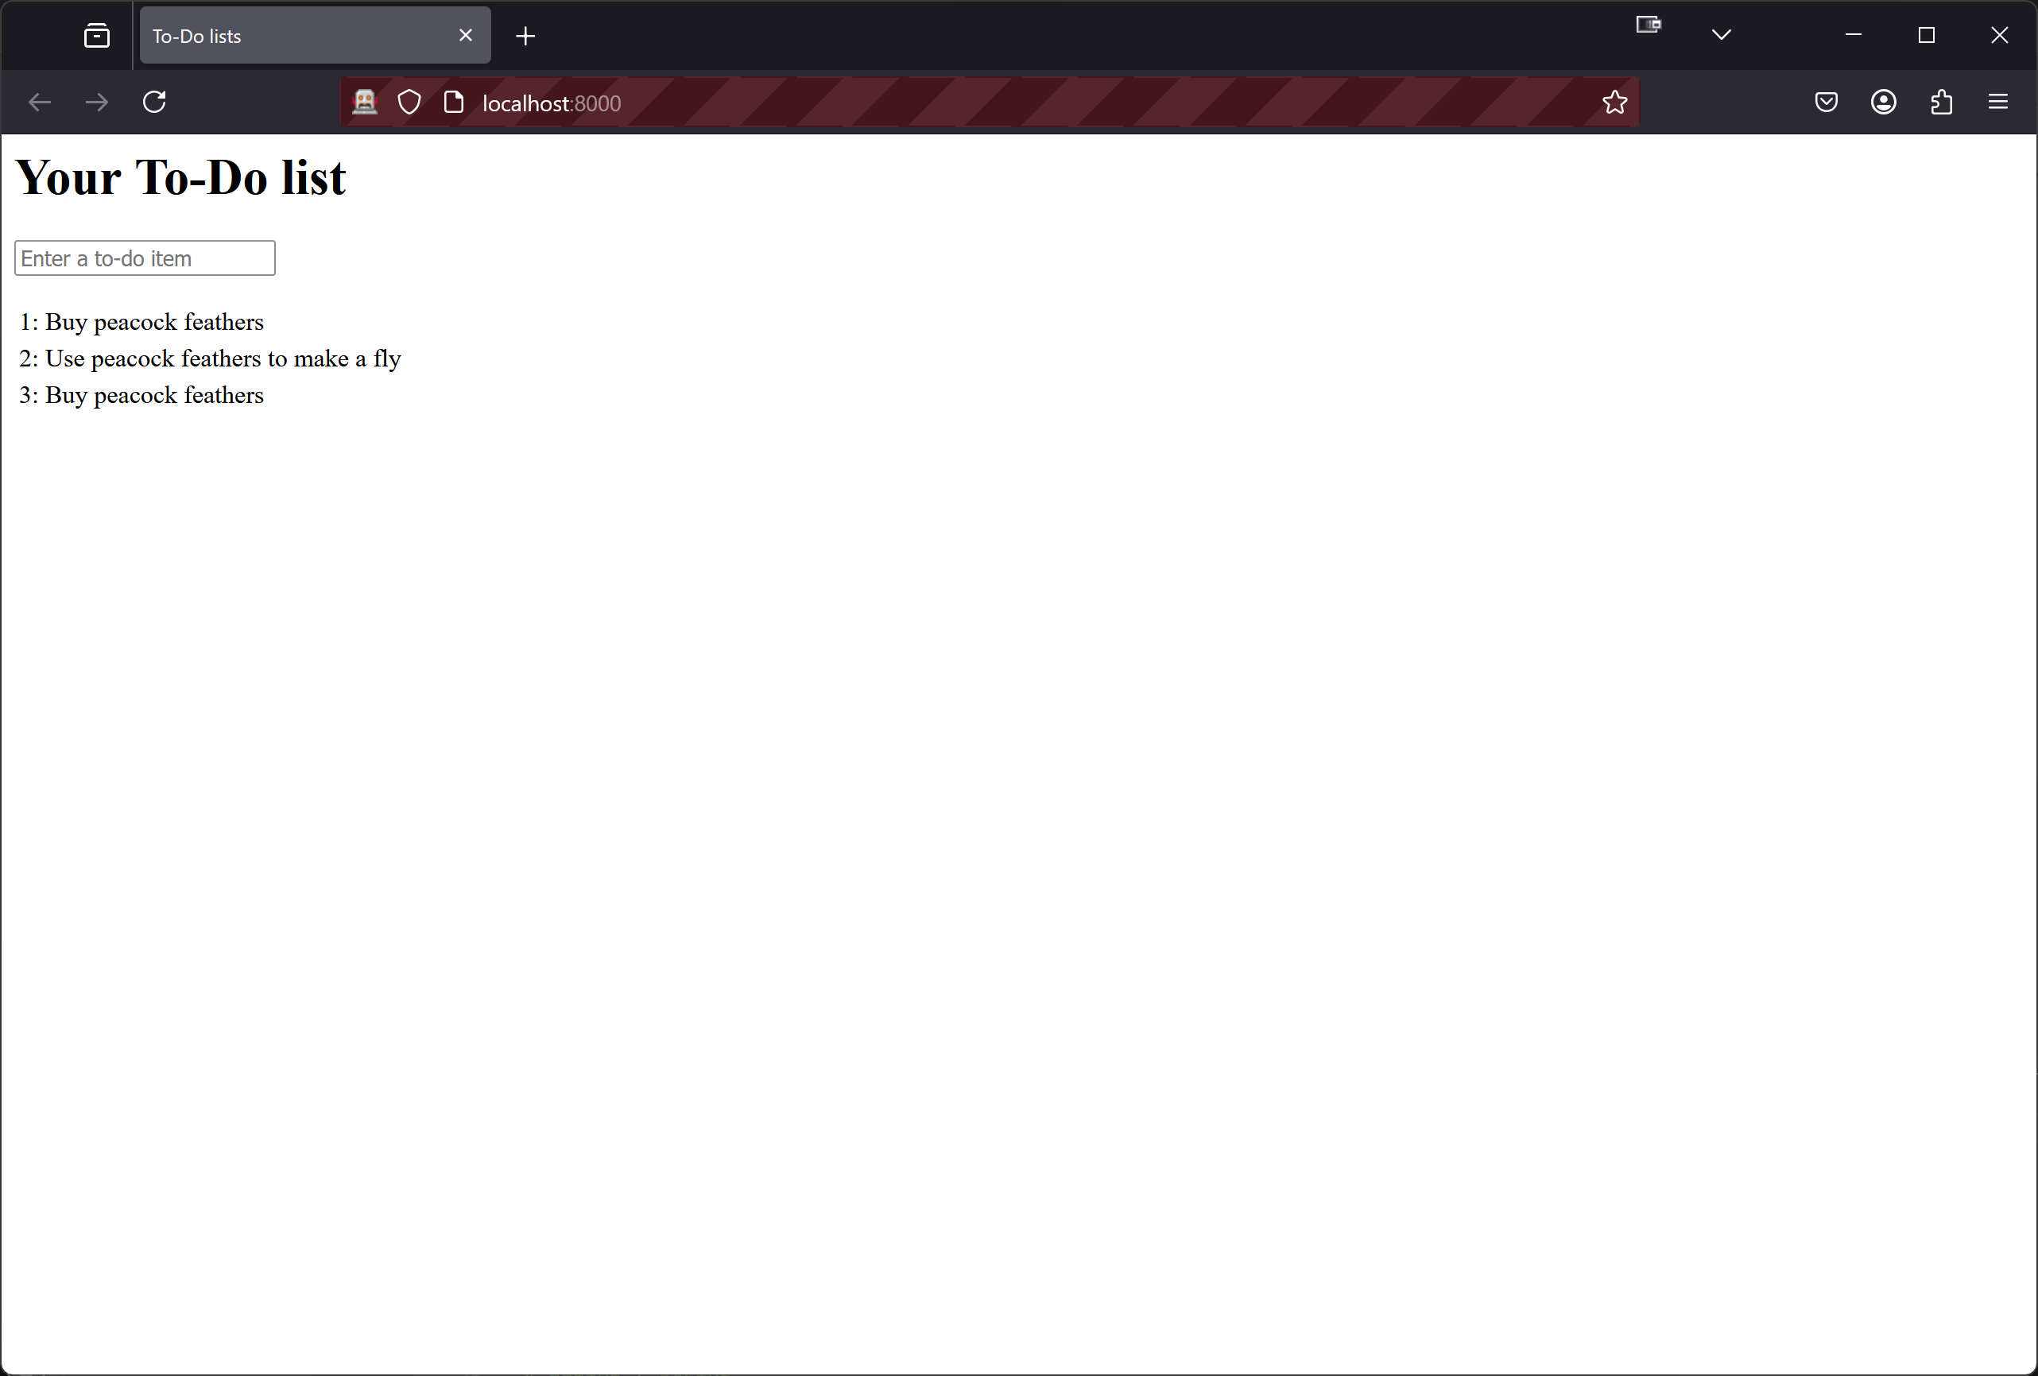

- Bash console after test
